**Problem Solving Process**

**Class 10**

**Lab 6**

|  |
| --- |
| Lab Objectives:  * Problem solving with while loop |

# Loop

## Loops are used in programming to repeat a specific block of code. In this article, you will learn to create a while loop in this lecture

# While Loop

## IMG_256a while loop is a control flow statement that allows code to be executed repeatedly based on a given Boolean condition.

## In while loop, test expression is checked first. The body of the loop is entered only if the test\_expression evaluates to True. After one iteration, the test expression is checked again. This process continues until the test\_expression evaluates to False.

## In Python, the body of the while loop is determined through indentation.

## Body starts with indentation and the first unindented line marks the end.

## Python interprets any non-zero value as True. None and 0 are interpreted as False.

# Flowchart of while Loop

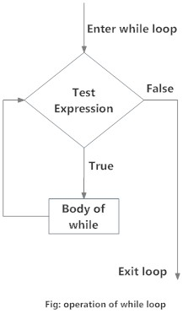

# 

# Example: while Loop

# Program to add natural

# numbers upto

# sum = 1+2+3+...+n

# To take input from the user,

# n = int(input("Enter n: "))

n = 10

# initialize sum and counter

sum = 0

i = 1

while i <= n:

sum = sum + i

i = i+1 # update counter

# print the sum

print("The sum is", sum)

## When you run the program, the output will be:

Enter n: 10

The sum is 55

## In the above program, the test expression will be True as long as our counter variable i is less than or equal to n (10 in our program).

## We need to increase the value of counter variable in the body of the loop. This is very important (and mostly forgotten). Failing to do so will result in an infinite loop (never ending loop).

## Finally the result is displayed.

# while loop with else

## Same as that of [for loop](https://www.programiz.com/python-programming/for-loop" \o "Python for loop), we can have an optional else block with while loop as well.

## The else part is executed if the condition in the while loop evaluates to False.

## The while loop can be terminated with a [break statement](https://www.programiz.com/python-programming/break-continue" \o "Python break statement). In such case, the else part is ignored. Hence, a while loop's else part runs if no break occurs and the condition is false.

## Here is an example to illustrate this.

# Example to illustrate

# the use of else statement

# with the while loop

counter = 0

while counter < 3:

print("Inside loop")

counter = counter + 1

else:

print("Inside else")

## Output

Inside loop

Inside loop

Inside loop

Inside else

## Here, we use a counter variable to print the string Inside loop three times.

## On the forth iteration, the condition in while becomes False. Hence, the else part is executed.

# What is the use of break and continue?

## break and continue statements can alter the flow of a normal loop.

## Loops iterate over a block of code until test expression is false, but sometimes we wish to terminate the current iteration or even the whole loop without checking test expression.

## The break and continue statements are used in these cases.

# Break statement

## The break statement terminates the loop containing it. Control of the program flows to the statement immediately after the body of the loop.

## If break statement is inside a nested loop (loop inside another loop), break will terminate the innermost loop.

# Syntax of break

break

# Flowchart of break

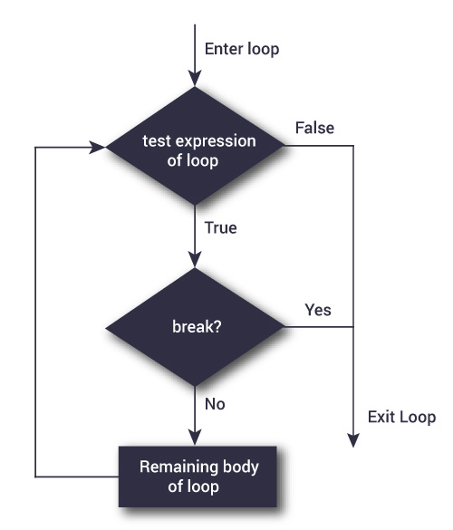

## How break statement worksThe working of break statement in [for loop](https://www.programiz.com/python-programming/for-loop" \o "Python for Loop) and [while loop](https://www.programiz.com/python-programming/while-loop" \o "Python while Loop) is shown below.